Essential Information for Your Visit

This pack has been prepared to provide the Group Leader with all the information they will need to plan a successful trip to a Shannon Heritage Attraction.
Please read carefully. Complete and return the school agreement form in good time and share appropriate information with your accompanying adults and students where necessary.
Updated Autumn 2022

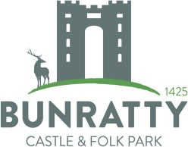

Contents

Opening Times 4
Getting to our Attractions 5
Running Late 7
On Arrival 7
Register 7
If you have booked a Guide 7
What’s included 8
The subsidised schools rate includes: 8
The subsidised schools rate does not include: 8
Unforeseen Closures 8
What to see and do 9
Bunratty Castle and Folk Park 9
Craggaunowen 10

What we expect from you 11 &12
Your students must be supervised at all times 11
What will happen if my student/s is /are separate from the accompanying adults? 11
Additional Needs 12
Inappropriate behaviour 12
Inappropriate behaviour includes but is not limited to 12
Terms and Conditions 13 &14
- CONTRACT 13
- BOOKING AND PAYMENT 13
- ALTERATIONS OR CANCELLATION OF BOOKINGS 13
- FORCE MAJEURE 14
- CHANGES BY THE COMPANY 14
- THE SCHOOL’S OBLIGATIONS AND RESPONSIBILITIES 14
- DATA PROTECTION 14
- GENERAL 15
- COMPLAINTS 15
- ARBITRATION 15
Facilities 16
Toilets 16
Lunch spaces 16
Packed Lunch Locations 16
Bags 16
Shopping 16
Accessibility 17
Additional Needs 17
Wheelchair Accessibility 17
Further Information 18
Teachers Resources 18
Our Staff 18
Smoking 18
Photography and filming 18
Eating and Drinking 18
Payment 18
Health and Safety Information 19
Supervision 19
Lost Children 19
Clothing 19
Insurance 19
Accidents/First Aid 19
In case of evacuation 19
Safeguarding children, young people and vulnerable adults 19
School Agreement Form 20
A Checklist for Teachers 21

Opening Times
Bunratty Castle and Folk Park

9:30am – 5.30pm
Closed 24th – 26th December inclusive

Please note Bunratty Castle is closed to day visitors from 4pm daily to prepare for evening entertainment.

Craggaunowen

March/April – September 9:30am – 4pm
Craggaunowen is closed mid September – 1st March/April – Exact dates are advised each season. These dates are subject to change; please check our website to confirm opening dates.

Closing date this year is September 17th 2022.

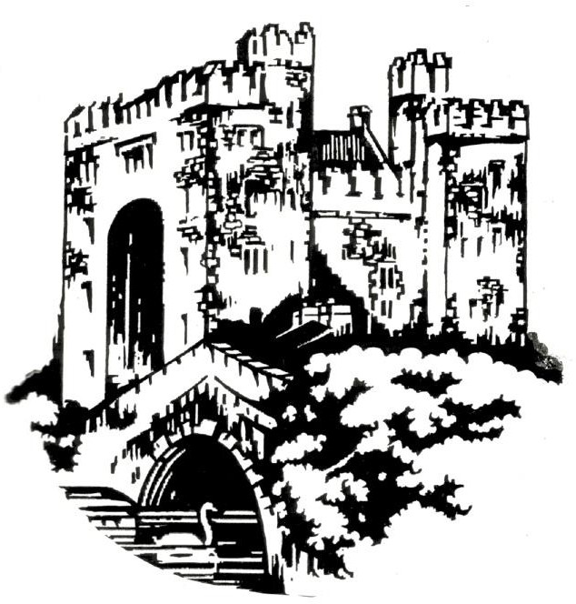

Getting to our Attractions

Bunratty Castle and Folk Park

Located just off the N18 Limerick/Ennis Road, just ten minutes from Shannon Airport. Coach Parking is on site across from the main entrance.
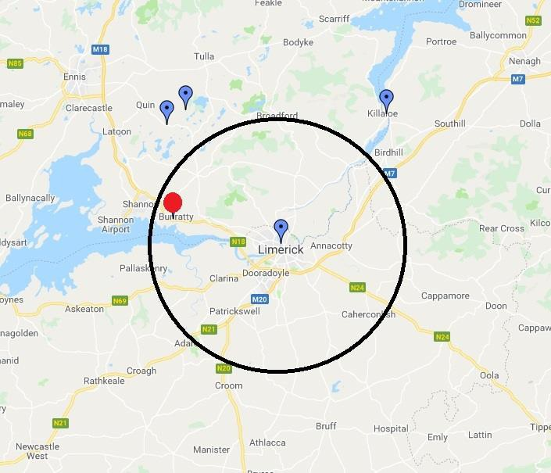
Bunratty Castle & Folk Park Bunratty
BUNRATTY CASTLE
& FOLK PARK
20 MINUTE JOURNEY
County Clare V95TY02
https://goo.gl/maps/39Q1dA5tvVP2

Craggaunowen

Located on the Ballyroughan Road off the R469 between the towns of Kilmurry and Quin, Co. Clare. Coach parking is on site.
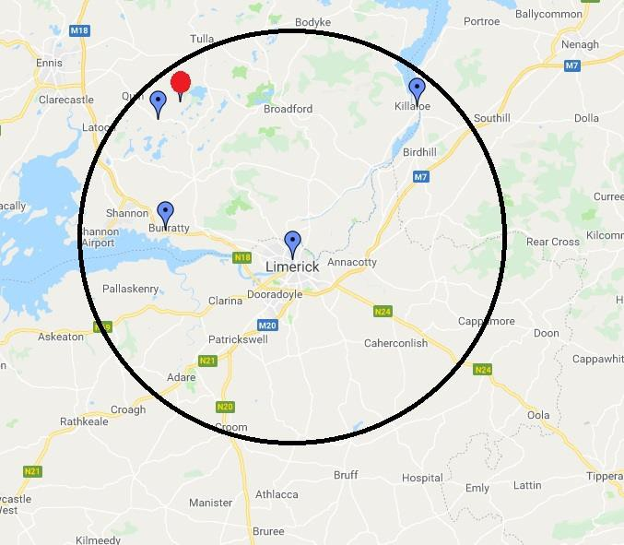
Craggaunowen Sixmilebridge County Clare V95 AD7E
CRAGGAUNOWEN
30 MINUTE JOURNEY
https://goo.gl/maps/YJy1oUWfCuu

Running Late
Travel Delays

We understand that you may experience delays when travelling with large groups.

If you have booked a guided tour and you are going to be late it is essential that you contact the Education Team on 061 711222 to provide an estimated time of arrival.
Guided tours or activities must not run beyond their scheduled times. However if you call ahead we will do our best to accommodate your group.

On Arrival

Register
All group leaders must go on arrival to the Reception/Admissions desk. Please note that all students must wait outside on buses while the group leader registers the group.

Collect Tickets
At the reception/admissions desk, all group leaders may collect admission material i.e. maps, learning materials as appropriate.

At the reception/admissions desk the group leader will be asked to provide

- Their name
- Their mobile number whilst on-site.
This information will be used to locate the group leader if any of your students are found unsupervised, or in the event of an emergency. Please keep your phone on at all times. Your contact details will be disposed of securely at the end of each day.

If you have booked a Guide for a particular activity.
Upon checking in you will be advised on where your guide will meet you.

Please note that guided tours are frequently booked out, if you miss your time slot we cannot guarantee that you will accommodated at another time.

What’s included

The subsidised schools rate includes:
- Access to the specific attraction chosen from Bunratty Castle and Folk Park or Craggaunowen. Brief introductory tours are offered subject to the availability of a guide.
- Self-led tours of the chosen attraction

The subsidised schools rate does not include:
- Guided tours of Bunratty Folk Park
- Activities
- Any evening entertainment including banquets and traditional Irish night.

Unforeseen Closures
At times, we may have to close certain areas of each attraction at short notice. You will be informed as soon as possible if this will have a major impact on your visit, otherwise please check the website for the most up-to-date information.
In the event of a closure due to a red weather warning we will reschedule your visit to a suitable date.

What to see and do

Bunratty Castle and Folk Park

Bunratty Castle
Irelands iconic Bunratty Castle is a must on your itinerary to Ireland. Named after the river Raite which runs alongside this strategic battlement. The spot on which this castle stands has been occupied for over 1000 years. From the Vikings to the Normans, great Irish Earls and noble Lords and Ladies. Graciously restored in the 1960's and furnished by Lord Gort’s magnificent collection of medieval furniture and furnishings, this is your chance to experience a window on Ireland’s past and explore the acclaimed 15th century Bunratty Castle.

The Folk Park
When you visit Bunratty's 19th Century Folk Park you experience a living reconstruction of the homes & environment of Ireland of over a century ago. Set on 26 acres, the impressive park features over 30 buildings in a ‘living’ village and rural setting. Rural farmhouses, village shops and streets are recreated and furnished as they would have appeared at that time according to their social standing, from the poorest one roomed dwelling to Bunratty House a fine example of a Georgian residence for the gentry built 1804 home of the Studdarts, the last family to occupy Bunratty Castle.

The Village Street
The village houses and shops in the Folk Park have been chosen from many different areas, to form a collection of typical 19th century urban Irish buildings including the School, Doctor’s house, Pawnbrokers, Pub, Drapery, Printworks, Grocery, Hardware shop, Pottery and a Post Office.
In the early 19th century the country people provided for most of their own needs in food, clothing and supplies and bought only luxuries such as sugar, salt and tea. Fairs and markets at the Village gave the farmers and the rural craftsmen an opportunity of selling their products for cash, while shops provided for the rural dwellers needs. However, during this time, exciting new products were becoming available in the local shops, which started to rival, and eventually replace, home production.
The village is set at a time of fundamental change in Irish society, and as such illustrates the growing money-orientated lifestyle of many of the villagers alongside the traditional, self-sufficient rural culture.
Bunratty House and Walled Gardens

A living reconstruction of the homes and environment of Ireland of over a century ago. Don’t miss the beautiful walled garden at Bunratty House. It is a surviving part of the demesne which was originally formed around Bunratty Castle. The garden was built for the house c 1804. As walled gardens go it is small, just less than half an acre, this was due to the fact that a large garden would have existed within the demesne, located north of the castle.

Children’s Fairy Village

The fairy people welcome visitors into their village but are notoriously shy and may not always appear themselves!

The Fairy trail and village are located in a pretty woodland section of this historic landmark. Ireland is famed for these magical creatures of myth and legend. The mystical creatures inhabiting the little fairy houses at Bunratty Folk Park have been here for quite some time living quiet yet productive lives. The fairy people welcome visitors into their village but are notoriously shy and may not always appear themselves!

Explore the fantastic new willow tunnel and willow hut in the surroundings of the magical forest trail. See a miniature Bunratty Castle and mini replicas of the houses that surround the folk park.

The Playground (strictly under 12’s only)

A world of adventure awaits. The playground located toward the end of the Village Street, features a timber structure housing 4 towers constructed from robinia wood with rope walks and belt bridges creates a fortified castellated fun filled tower that gives vantage views to the surrounding country landscape. Further features include a play ship theme, a 25m zipline, and a variety of swings.

Craggaunowen
The Castle
Tower houses are more numerous than the larger castles found mainly in towns and cities where representatives of the crown ruled. The castle was lived in by the Chieftains of Irish families for over 3 centuries until the wards of the 17th Century. Generally the ground floor was reserved for storage and domestic animals, the first floor and second floor were sleeping quarters and banquets. The guard’s house was on the left on entry to the Castle.

The Crannog
Each Crannog was the home of one family. The people that lived on the crannog placed sharp pointed branches in the water to stop enemies approaching by boat. Flat stepping stones were places just beneath the water surface as a secret pathway.
The Togher – An Iron Age Road
Wedges were forced into the tree trunk to split it in two, forming rough planks, which formed the wooden road.

Dolmen
Dolmens are often called portal tombs, marking burial places. They were created between 3000 BC and 2000 BC and were generally always kept as tombs, though they may also have had a ritual significance.
The Ringfort
The dwelling houses inside the Ringfort were built of stone with a thatched roof which was supported by wooden poles. Remains of these first can still be seen throughout the country, they are known as ‘fairy forts’ and are regarded as magical places.

The Brendan
The Brendan Boat is on display in a glass pyramid, supported above a small pool of water which helps to keep the air moist, so the leather hull does not split. It is believed that St Brendan and his sailors were probably born and raised in homes like the Ringfort at Craggaunowen.

What we expect from you
Shannon Heritage operates award winning attractions. These are all sites of significant historical importance. We welcome all visitors of all ages, however the environment on site is very different to that of a school.

We find it helpful for all group leaders to know our expectations for student behaviour while visiting the various sites. It also helps our staff know how best to help you during your visit and ensure that the many school groups that visit do not distract other visitors.

Please share the following information with all your accompanying adults to help them feel confident about leading a group while they are visiting. You may also want to discuss certain issues related to your visit prior to the day.

Your students must be supervised at all times
You are responsible for the health and safety of your students during your visit to any Shannon Heritage attraction, whether on a self-led, guided visit, in a shop, while eating lunch, or at any other location on site.

We interpret supervision to mean that accompanying adults will remain in the physical presence of the group of students for which they are responsible at all times. No students should be allowed to move around without an adult with them at all times. That includes students engaged in worksheet exercises.

We offer 1 free adult admission per 10 children, the ratio of 1 adult per 10 students is the recommended amount for all our sites. However for junior national school classes (junior infants to 1st class) we recommend a higher number of adults, 5 children per adult. These supervising adults will also be admitted free of charge. Shannon Heritage retains the right to refuse entry to groups without a sufficient number of accompanying adults.

Please be sure to divide your students into smaller groups when entering individual buildings.

By following these guidelines, you will help all other school groups and general visitors to have an enjoyable visit, and will assist staff to provide a better customer service experience.

What will happen if my student/s is /are separate from the accompanying adults? The combination of enthusiastic young learners and a busy visitor site may result in students becoming separated from their accompanying adult.

If a student or students have strayed from their assigned adult, please approach a member of staff who will be able to help you.

They will need to know a description of the student/s concerned, the name of your school.

If student/s have strayed from their accompanying adult and are found by a staff member, and their adult cannot be easily found, they will ask your students/s to accompany them to an easily accessible location on the route. Your student/s will be asked to provide their name/s, the name of their school and their group leaders.

Our staff will then use the details you supplied on entry to contact you, providing details of where you can meet your student/s. Please keep your mobile phone on and check it regularly, remembering that the number used to contact you will not show up as one of your contacts.

Additional Needs
As per the terms and conditions, please let us know as soon as possible if any of your students have special educational needs and /or health or mobility difficulties. We can be contacted on 061 711222 or education@shannonheritage.com. We will make every effort to maximise their enjoyment of the day, for example, by providing additional free places for SNA’s.

Inappropriate behaviour
Shannon heritage has thousands of students visiting a year and almost all visits pass without incident. However, a small number of incidents do occur with school groups, which could spoil your visit and that of other people. Most inappropriate behaviour has occurred when students were left unsupervised, which is why we insist students are supervised at all times during your visit.

Inappropriate behaviour includes but is not limited to:
- Fighting
- Taunting or chasing .resident animals
- Playing ball games on visitor routes
- Taunting or distracting other tours on site
- Straying into secure areas off the visitor route
- Shoplifting
- Heckling staff members
- Littering
- Taking photographs in places where it is forbidden
- Smoking
- Any actions that have a detrimental effect on any other visitors enjoyment of the attraction
If an incident occurs then a member of staff will contact the group leader to meet their unsupervised student.
Our staff members are instructed to leave all disciplinary matters related to such incidents with the group leader. However, our staff can exclude students if they feel their behaviour is having a detrimental effect on other visitors’ enjoyment of the attraction. If this happens a member of staff will contact you using the details left at admissions/reception.

Terms and Conditions

BOOKING TERMS AND CONDITIONS FOR SCHOOL TOURS

The following booking terms and conditions contain important information, so it is essential that you carefully read and understand them.

CONTRACT
  - Once the Company confirms your booking a Contract is made Shannon Heritage DAC (hereinafter called “the Company”) and the School (each a “Party” and together the “Parties”) upon the terms and conditions set out herein (the “Contract”).

  - The Company will only confirm a booking once full written agreement has been received by the Company. No contract between the School and the Company shall come into existence until the Company accepts full payment in advance or upon arrival as confirmed in advance.

  - The Company accepts no responsibility for incorrect email or inability to deliver email. If the confirmation of the booking does not arrive on time or at all, then the School must inform the Company and ask the Company to resend the booking confirmation.
  - The person who makes the booking accepts these conditions set out herein on behalf of the School and is responsible for all payment due from the School.

  - By making the booking the School confirms that they have received the permission from the child’s parent or guardian to attend the tour when a child is under 18 years old.

BOOKING AND PAYMENT
  - It is the responsibility of the School to check the confirmation email carefully and inform the Company in the event of any errors in advance of the tour.

  - The School must make full payment to the Company at the time of booking the tour or immediately upon arrival.

ALTERATIONS OR CANCELLATION OF BOOKINGS
  - The School may amend or cancel a booking. All amendments or cancellations must be emailed in advance to the Company.

  - If the School informs the Company of a cancellation after the visit confirmation date the School will not be refunded for any payment that has been made.

  - If the School needs to add extra students or supervising adults or reduce the number of students or supervising adults to the tour these amendments need to be communicated to the Company.

  - The Company will not give any refunds for cancellations after the Amendment Deadline or if the School fails to arrive on the tour date.

FORCE MAJEURE
  - Neither party will be liable to the other party for failure to fulfil their obligations under this Contract as a result of any circumstances outside its reasonable control including, without limitation the generality of the foregoing an Act of God, flood, fire, accident, explosion, war, civil commotion, strike or other industrial action, or any act of a third party government or quasi-government organisation.

CHANGES BY THE COMPANY
  - The Company will make every effort to operate all tours as advertised but the Company reserves the right to alter the typical itinerary of the tour at any time and at the Company’s discretion. The Company will endeavour to avoid this and if this is necessary, the Company will substitute alternative arrangements of comparable monetary value.

  - Every effort is made to ensure the accuracy of the Company’s brochures and other printed material at time of going to print, however the Company cannot be held responsible for printing and typographical errors, or changes in the itinerary arising from unforeseen circumstances after the material has gone to print.

THE SCHOOL’S OBLIGATIONS AND RESPONSIBILITIES
    - Supervising adults must remain with the tour group and supervise students at all times for the duration of the tour.

    - The School is responsible for ensuring that all supervising adults in the tour group are aware of the supervision requirements.

    - The Company reserves the right to refuse entry to tour groups who do not have enough supervising adults present for the number of students, with no possibility of a refund.

    - If the School arrives late on the day of the tour they may be refused entry on the tour, with no possibility of a refund.

    - The School must inform the Company at the time of booking of any physical or special needs condition of any member of the group which may be relevant. The Company reserves the
right to decline to provide a tour to any person who in the Company’s opinion would be inconsistent with the special needs of that person.

    - It is the responsibility of the School to check the accuracy of the booking confirmation.

DATA PROTECTION
The Company is committed to protecting the School’s privacy and information. The information that the Company’s uses is for the purpose of fulfilling the Company’s obligations as an organiser of a tour.

GENERAL

  - The booking conditions detailed herein contain the entire contract between you and the Company. No representation, term, warranty or condition can be expressed or implied by reference to any other writing, advertisement or conversation. This Contract may only be varied in writing by a duly authorised officer of the Company.

  - This Contract and all matters arising out of it are governed by Irish law. Both parties agree that any dispute, claim or other matter which arises out of or in connection with this Contract will be dealt with by the Courts of the Republic of Ireland only.

COMPLAINTS

  - If the School or the School’s representative wishes to make a complaint in relation to the tour, they must immediately inform the Company’s representative at the location where when the complaint arises and shall if the Company requires, complete a form setting out the detail of the complaint. The School shall be obliged to notify the Company in writing of any complaint not later than 28 days after the tour date, no complaint received thereafter shall be entertained.

ARBITRATION

Any dispute or difference of any kind whatsoever which arises or occurs between any of the parties hereto in relation to anything or matter arising under, out of or in connection with the contract and/or the booking connected to this contract shall be referred to arbitration under the Arbitration Rules of the Charted Institute of Arbitrators. Claims for less than the jurisdiction of the District Court Small Claims Procedure per booking form may be pursued through the District Court Small Claims Procedure. All claims in excess of the jurisdiction of the District Court Small Claims Procedure shall be referred to arbitration.

Facilities

Toilets
There are toilet facilities located at all attractions.

Lunch spaces
We are unable to offer all groups a lunchroom. We have some sheltered areas at some of our attractions in the case of inclement weather however these are not available at all times and are subject to availability. Please see below.

Packed Lunch Locations
Bunratty Castle and Folk Park

- The Hay shed (if available)
- The Corn Barn close to the Entrance/Exit building (if available)
- Outdoor designated area
Craggaunowen
- Outdoor
- No covered area available
Shannon Heritage operates a packed lunch policy provided by the school or students themselves.

Bags
There are no locker or cloakroom facilities at our attractions. We recommend leaving all personal belongings and valuables especially on the bus.

Shopping
When visiting any of our shops we would advise going in small groups.

Accessibility

Additional Needs
Please let us know as soon as possible if any of your students have special educational needs and /or health or mobility difficulties. We can be contacted on 061 711222 or education@shannonheritage.com. We will make every effort to maximise their enjoyment of the day, for example, by providing additional free places for SNA’s.

Wheelchair Accessibility
While every effort is made at all Shannon Heritage attractions to ensure full Wheelchair Accessibility due to the nature of some of these ancient sites it is not always possible. Please see accessibility issues below.

Bunratty Folk Park

The Folk Park is accessible by wheelchair and has full toilet facilities on site. Bunratty Castle
Please note that access to the interior of the castle is by steps only except for the basement exhibition.

Craggaunowen

Craggaunowen as our most ancient site is partly inaccessible for wheelchairs. The paths are uneven and muddy in parts but can be negotiated. Craggaunowen Castle is not accessible. There are There are wheel chair accessible toilets on site in Craggaunowen.

Further Information

Teachers Resources
Please see our websites for further teacher resources. If you have a booked a guided tour or activities, you will find your teacher notes for the session on our websites.

www.bunrattycastle.ie

www.craggaunowen.com

www.shannonheritage.com

Our Staff
Members of our guiding staff are here to help you and will be pleased to answer your questions, including any queries you may have about the history of each site. Please treat our staff with courtesy and professional respect, remembering that they are responsible for ensuring a good experience for all our visitors.

Smoking
Smoking is not permitted in any of our attractions.

Photography and filming
Visitors are welcome to take photographs within most areas. Photographic equipment, such as tripods and selfie-sticks should not be used inside the buildings. Photography is not allowed in the following areas:

- All areas inside of Bunratty Castle.
Shannon Heritage is a safeguarding aware organisation and takes its responsibility to protect children and vulnerable adults seriously. If you have concerns about photography of your group, please speak to a member of staff.

Eating and Drinking
Please do not eat or drink in any of the historic areas and buildings.

Payment
We accept the following payment types

- Cheque – made payable to ‘Shannon Heritage LTD’
- Bank Transfer
- Credit Card
Please note all tours must be paid in full prior or upon arrival. See Terms and Conditions.

Health and Safety Information
We carry out risk assessments on all our activities and we have assess the risks associated with visiting our attractions as low but please remember the site is open to the public and consider this when planning your visit.

Supervision
Your students must be supervised at all times. We interpret supervision to mean that at all times accompanying adults will remain in the physical presence of the group of students for which they are responsible. No students should be allowed to move around the various sites without an adult with them. This includes when students are completing worksheets and other activities. We recommend a ratio of 10 students per 1 adult. Please be sure it break up your students into smaller groups when entering individual building within the various sites.

Lost Children
If a student/s has strayed from their assigned adult please approach a member of staff as soon as you notice and they will be able to help you. They will need to know a description of the student/s concerned, the name of your school. If student/s have strayed from their accompanying adult and are found by a staff member, we will use the contact details you supplied on entry to contact you, providing details of where you can meet your student/s. Please keep your mobile phone on and checked regularly.

Clothing
Please make sure that your group is suitably dressed for the day’s activities. Large parts of all visits are spent outside, or in spaces with little or no heating. Please make sure your group is wearing suitable footwear and is equipped with wet weather clothes and/or protection from the sun. We recommend that all visitors have a change of clothes on the bus.

Insurance
The School shall keep itself insured with a reputable insurance company against all insurance liability with appropriate cover in respect of the visit to the Company’s sites. It is the responsibility of the School to make sure they have the appropriate insurances in place prior to the tour.

Accidents/First Aid
If there is an accident or near accident during your visit, please find the nearest member of staff who will be able to help you. First aid is always available and a record will be made of any accident that occurs.

In case of evacuation
Please respond to directions given by members of staff.

Safeguarding children, young people and vulnerable adults
Our aim is to help everyone explore the history of our sites. This welcome to everyone includes children, young people and vulnerable adults. Our full safeguarding statement is available on our website. Reporting: If a safeguarding incident occurs while you are on site please report this immediately to a member of staff

School Agreement Form
Please complete this form and return it by email to the education team at Shannon Heritage in advance of your visit.

Name of School: ………………………………………………………………………………………………………….. Date of Visit: ………………………………………………………………………………………………………………. Name of Group Leader: ………………………………………………………………………………………………. Booking reference number: …………………………………………………………………………………………

I, the undersigned, confirm that I have capacity to enter this Agreement on behalf of the visiting school. I also confirm the following:

- I have read, understood and agree with the information and conditions provided in the ‘Essential information for your visit’ information pack.
- The visiting school/group has appropriate insurance in place to cover their visit to any Shannon Heritage site.

Signature: …………………………………………………………………………………………………………………………….. Date: ……………………………………………………………………………………………………………………………………. Print Name: ………………………………………………………………………………………………………………………….. Position in School: …………………………………………………………………………………………………………………..

Please return this form in advance of your visit by email to: education@shannonheritage.com

Education Shannon Heritage
Bunratty Castle and Folk Park Bunratty
Co. Clare V95 TY02

A Checklist for Teachers

Before your visit, please work through the checklist below, to ensure that everything is ready for your trip to a Shannon Heritage attraction.

€ Date of your Trip.

€ Time of your visit.

€ Have you confirmed any activities or guide?

€ Carefully plan you journey, allowing some extra time for travel delays.

€ Read the Essential Information Pack and Teachers Notes.

€ Sign and return the School Agreement form in the Essential information pack.

€ Ensure you are bringing a sufficient amount of adults.

€ Inform us of any changes to your group numbers, this is to ensure a smooth admission.

€ Tell us about any accessibility issues so we can accommodate them as much as possible.

€ Remind the group to wear appropriate clothes and footwear as a large part of your visit will take place outside.

€ Ensure that all accompanying adults have a timetable for the day and any directions they will need to meeting points.

€ Share your emergency contact numbers with all accompanying adults.

€ In the days before your visit, check our website and social media for any news of last minute closures.

€ Have your contact number ready to share with a member of staff upon registration at the admissions desk.

€ Make sure you have a telephone number to call if you are running late on the day. 061 711222.

